**Data Entry:**

1. Enter the details of a new instructor.

(If there is an insert error, you should delete the row by yourself because we initially use logical deletion in our database)

**INSERT INTO** staff_info ( staffNo, staff_fName, staff_lName, staff_status, staff_sex, staff_address, staff_phone, staff_id, staff_birth, staff_expertise, staff_email )

**VALUES**

( "t0001", "Zhang", "San", "1", "M", "Macau SAR, China", "86 13011111111", "440681xxxxxxxxxxx0", #1980-01-01#, "painting", "zhang@gmail.com" );

1. Enter the details of a new student.

(If there is an insert error, you should delete the row by yourself because we initially use logical deletion in our database)

**INSERT INTO** student_info ( studentNo, student_fName, student_lName, student_status, student_sex, student_birth, student_id, student_phone, student_address, student_email )

**VALUES**

 ( "p2211001", "John", "Wu", "1", "M", #2003-09-01#, "12345", "130xxxxxxxx", "HongKong, China", "J" );

1. Enter the details of a new course.

**INSERT INTO** course_info ( courseNo, course_name, course_dsc, course_pre )

**VALUES**

( "c00001", "Sketch", "good", Null);

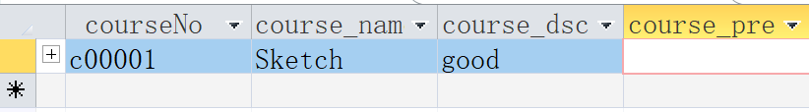

1. Enter the details of a new class section before a new semester begins.

**Initially we design “section_year” attribute as YEAR, but my computer’s app doesn’t support it yet due to the lower version. So we contemporarily use INT to replace it.**

**INSERT INTO** class_section_info (sectionNo, associated_course, section_course_day, section_course_time, section_course_duration, instructor, assignment, section_semester, section_year)

**VALUES**

 ("section-0001", "c00001", "MON", "14:30-17:30", "2023/09/01-2023/12/01", "t0001", "No work", "1", 2023);

1. Enter the details of a new class material when it is needed.

**INSERT INTO** course_material_info ( document_id, document_author, document_title, document_topic, associated_section, created_time, modified_time )

**VALUES**

 ( "document-0001", "t0001", "textbook", "t", "section-0001", #2023-09-01 15:00:00#, #2023-09-01 15:00:00# );

1. Enter the details of a new artwork when it exists.

**INSERT INTO** artwork_info ( artworkNo, artist, artwork_created_time, artwork_submitted_time, artwork_format, artwork_subject, artwork_used_medium, instructor, associated_section )

**VALUES**

(1, "p2211001", #2023-11-11 17:00:00#, #2023-11-12 10:00:00#, "jpg", "Sun", "crayon", "t0001", "section-0001");

1. Enter the details of a new evaluation when there is an artwork.

**UPDATE** artwork_info

**SET** evaluation_written_date = #2023-11-13#,

evaluation_grade = "A",

evaluation_remark = "excellent"

**WHERE** artworkNo = 1;

**Data Update / Deletion:**

1. Update / delete the details of an instructor.

**UPDATE** staff_info

**SET** staff_phone = "6859xxxx",

staff_address = "Macau",

staff_email = "12345@qq.com"

**WHERE**

 staffNo = "t0001";

**UPDATE** staff_info

SET staff_status = "0"

**WHERE**

staffNo = "t0001";

(It won’t be select as a row when doing a query)

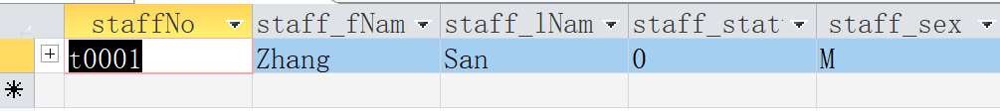

1. Update / delete the details of a student.  
     
   **UPDATE** student_info

**SET** student_phone = "",

student_address = "Macau",

student_email = "23456@qq.com"

**WHERE**

 studentNo = "p2211001";

**UPDATE** student_info

**SET** student_status = "0"

**WHERE**

studentNo = "p2211001";

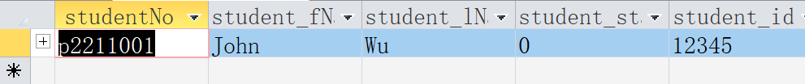

1. Update / delete the details of a course.

**UPDATE** course_info

**SET** course_dsc = "It is a sketch class.",

course_pre = "paintbrush"

**WHERE**

courseNo = "c00001";

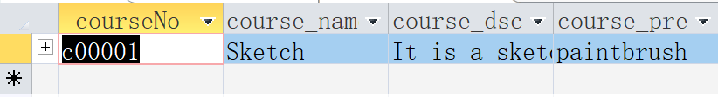

**DELETE**

**FROM**

course_info

**WHERE**

courseNo = “c00001”;

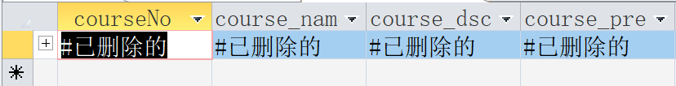

1. Update/Delete the details of a class section.

**UPDATE** class_section_info

**SET** assignment = "exercise",

section_course_day = "TUE"

**WHERE**

****sectionNo = "section-0001";

**DELETE**

**FROM**

class_section_info

**WHERE**

sectionNo = "section-0001";

1. Update the details of a class material.

**UPDATE** course_material_info

**SET** document_title = "T1",

document_topic = "sketch",

modified_time = #2023-11-29 10:48:00#

**WHERE**

document_id = "document-0001";



1. Update/Delete the details of an artwork.

**UPDATE** artwork_info

**SET**

artwork_format = "png"

**WHERE**

 artworkNo = 1;

**DELETE**

**FROM**

artwork_info

**WHERE**

 artworkNo = 1;

1. Update the details of an evaluation of the artwork.  
   **UPDATE** artwork_info

**SET** evaluation_grade = "B",

evaluation_remark = "Good",

evaluation_written_date = #2023-11-29 10:48:00#

**WHERE**

 artworkNo = 1;

**Data Queries:**

The database should be capable of supporting the following sample queries:

1. List the classes assigned to a given instructor.

(To make the selection more detailed, we insert one more teacher and 2 related section)  
**SELECT**

a.staff_fName,

a.staff_lName,

b.*

**FROM**

staff_info a

**INNER JOIN** class_section_info b **ON** b.instructor = a.staffNo

**WHERE**

b.instructor = "t0003"

 **and** a.staff_status = "1";

1. Identify the total number of enrolled students.

(To make the selection more detailed, we insert two more students and 5 related enrollment)  
**SELECT COUNT(**\***) AS** total_enroll_student

**FROM**

**(SELECT DISTINCT** a.studentNo

**FROM** student_section_registration **AS** a

**INNER JOIN** student_info **AS** b **ON** b.studentNo = a.studentNo

**WHERE** a.enroll_date > #2023-09-01# **AND** b.student_status = "1"**) AS** subquery;

(Because of banned row of “p2211001” and previous record of “p2211002”, there is only one record of “p2211003”)

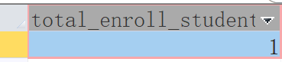

1. Search for student’s artwork and its associated course, assignment.   
   **SELECT**

d.student_fName AS artist_fName,

d.student_lName AS artist_lName,

a.artwork_created_time AS created_time,

a.artwork_submitted_time AS submitted_time,

a.artwork_format AS artwork_format,

a.artwork_subject AS artwork_subject,

a.artwork_used_medium AS artwork_used_medium,

e.staff_fName AS instructor_fName,

e.staff_lName AS instructor_lName,

c.course_name AS course_name,

b.assignment AS assignment

**FROM**

(((artwork_info a

**INNER JOIN** class_section_info b **ON** a.associated_section = b.sectionNo)

**INNER JOIN** staff_info e **ON** a.instructor = e.staffNo)

**INNER JOIN** course_info c **ON** b.associated_course = c.courseNo)

**INNER JOIN** student_info d **ON** a.artist = d.studentNo

**WHERE**

d.studentNo = "p2211001";

1. Search for the evaluation of student’s artwork.   
   **SELECT**

a.artworkNo,

d.student_fName **AS** artist_fName,

d.student_lName **AS** artist_lName,

a.artwork_subject **AS** theme,

e.staff_fName **AS** instructor_fName,

e.staff_lName **AS** instructor_lName,

c.course_name **AS** course,

b.assignment **AS** assignment,

a.evaluation_grade **AS** grade,

a.evaluation_written_date **AS** written_date,

a.evaluation_remark **AS** remark

**FROM**

(((artwork_info a

**INNER JOIN** class_section_info b **ON** a.associated_section = b.sectionNo)

**INNER JOIN** student_info d **ON** a.artist = d.studentNo)

**INNER JOIN** staff_info e **ON** a.instructor = e.staffNo)

**INNER JOIN** course_info c **ON** b.associated_course = c.courseNo

**WHERE**

a.artist = "p2211001"

 **AND** a.evaluation_written_date **IS NOT NULL**;

1. Search for the class materials.   
   **SELECT**

c.course_name,

a.document_topic,

a.document_title,

a.document_author,

a.created_time,

a.modified_time

**FROM**

(course_material_info a

**INNER JOIN** class_section_info b **ON** a.associated_section = b.sectionNo)

**INNER JOIN** course_info c **ON** c.courseNo = b.associated_course

**WHERE**

a.document_id = "document-0001";



1. Search a student’s class by time, and course name.  
   **SELECT**

b.student_fName **AS** student_fName,

b.student_lName **AS** student_lName,

d.course_name,

c.section_course_day,

c.section_course_time,

c.section_course_duration,

e.staff_fName,

e.staff_lName,

c.assignment,

c.section_semester,

c.section_year

**FROM**

(student_course_registration a

**INNER JOIN** student_info b **ON** b.studentNo = a.studentNo)

**INNER JOIN** ((class_section_info c

**INNER JOIN** course_info d **ON** c.associated_course = d.courseNo)

**INNER JOIN** staff_info e **ON** c.instructor = e.staffNo)

**ON** c.sectionNo = a.sectionNo

**WHERE**

a.studentNo = "p2211001"

**AND** a.enroll_date > #2023-09-01 00:00:00#

 **AND** d.course_name = "Sketch";